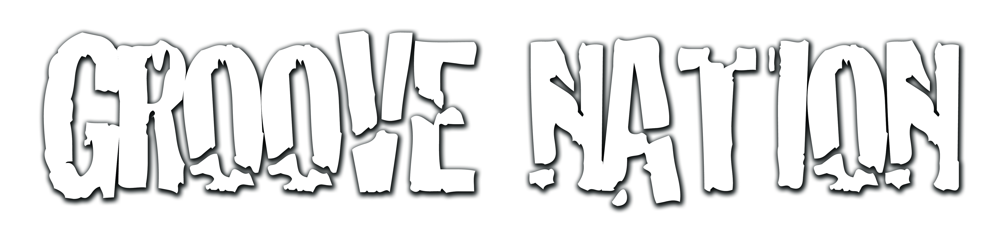

Workshops & Showcase
email: groovenationworkshops@gmail.com
facebook: Groove Nation Workshops
Twitter: @GNWorkshop

Groove nation workshops, is a finely tuned dance and performance-based company geared toward aspiring talent. This uniquely packaged workshop intensive is designed to educate, challenge and prepare todays talent in a healthy and nurturing yet aggressive learning environment. Our purpose is to prepare these young hungry minds by industry standards through industry level professionals. Our experienced, caring and highly accredited instructional staff, are here to help bridge the gap and raise the bar!

ARE YOU READY FOR AN AMAZING EXPERIENCE?? LET’S GET YOU REGISTERED!

Name of Dancer: ____________________________________ School or Crew: _______________________

Date of birth: M/D/Y____/______/_____ Gender of Dancer: _______ Age Of Dancer: _______

Jr. 8 -12yrs ___ Sr. 13 &up ___ Email: __________________________________________________

Name of Parent/Guardian: ___________________________________ Contact #: ____________________

How did you hear about us? Facebook__ Word Of Mouth__ Email__ Twitter__ Other __
Have you added us on Facebook to receive info on future Groove Nation Events?

WE WILL BE GIVING AWAY SCHOLARSHIPS TO DANCERS WHO DISPLAY EXCEPTIONAL PERFORMANCE. This may include possibly assisting our team in future workshops.
Kindly indicate if you are a past recipient of a scholarship by email along with registration!

Read and sign the following release, parent Release & Indemnity Agreement 2017 Groove Nation Workshops.

As parent/guardian of ____________________________, I hereby release Groove nation Workshops/independent contractors and its staff from all liability and claims due to any injuries illness or property damage, which may be sustained to or by myself son/daughter while attending the Groove Nation workshops Nov. 4th 2017. I am aware that the attendance or participation of myself son/daughter in any and all dance or associated events with Groove Nation Workshops involves dance bodily exercise movement and rigorous activity. I am fully aware of I, my son/daughters medical conditions and hereby certify mental and physical fitness to participate in the class for which myself son/daughter have registered for on Nov. 4th 2017. I hereby authorize Groove nation Workshops/independent contractors and its staff to take and use photographic and video footage of myself/son/daughter for future promotional use. I also understand that money will be refunded in full if the Groove Nation workshop is completely cancelled and not rescheduled with any alternative. Other than that there are no refunds.

Signature of Participant or Guardian of Participant: __________________________________

Witness Name: __________________________ Witness Signature:_____________________________

Date: M/D/Y ______________________

- Early Bird Jr./Sr. Workshop price - £ 25
- Oct 21st is The cut off for registration thereafter The price is £35
- Cash payment Only
- Contact Lauren @ 07713157097 to make payment arrangements

